Grille de satisfaction

  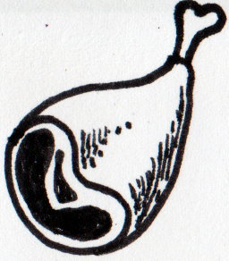  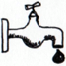  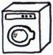    Critères | Tour 1 |  | Tour 2 |  | Tour 3 |  | Tour 4 |  | Tour 5 |  | Tour 6 |  | Tour 7 |  | Tour 8
Espéré / Satisfait | E | S | E | S | E | S | E | S | E | S | E | S | E | S | E | S
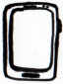 | 2
  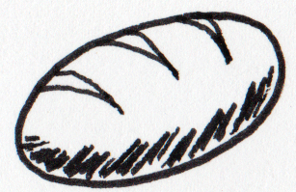  = + | 4
 | 2
 | 2
 | 1
 | 1
Satisfaction

Population
Production

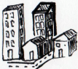
Coûts
Besoins  : 41  x 3 = 123  Services  = 1 + 5  x = + | Limites |  |  |  |  |  | par | total
 |  |  |  |  |  |  | 2
 | 1 3 |  |  |  |  |  | 2
= + |  |  |  |  |  |  | 4
 | 3,5 4,5
 |  |  |  |  |  |  | 2
 | 0,5 3
soit | / |  |  |  |  |  | 2
 |  |  |  |  |  |  | 2
 | 0,5 3 |  |  |  |  |  | 2
 | / |  |  |  |  |  | 1
 | / |  |  |  |  |  | 1
Services |  |  |  |  |  |  | 1/15
Services | 1/45 1/8 |  |  |  |  |  | 1/15

Agriculture et assimilés
Zone de captage

Surface totale : 247
dont construite : 109
Soit surface de captage : 138

x3 =
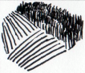 | Nombre | Coût |  |  |  |  |  | Production
 | Nombre |  | total |  | total |  | total | ou
Champs | 36 | 0,4 |  | 1 |  | 0 |  | x7
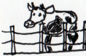  Élevage | 74 | 0,5 |  | 1 |  | 0 |  | x3
Total

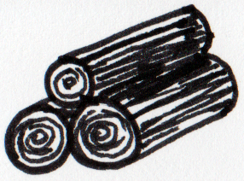
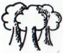
Coûts
Forêt

En construction : =
(délai : 1 tour)

Coupée : =

Production
Extraction

Mines et carrières
Éoliennes

7x 5 =

Usure 1
2
3
4
5
6
7

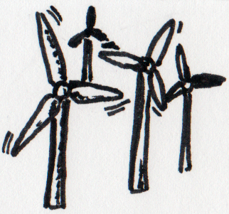
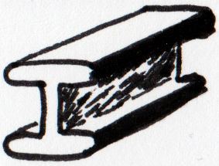  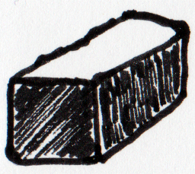  Nom  Coûts  Production | Age |  |  |  |  |  | coût |  |  | Production
Met 1 |  |  |  |  |  |  | 1 | 3 | 1 | 18
Met 2 |  |  |  |  |  |  | 1 | 3 | 1 | 18
Met 3 |  |  |  |  |  |  | 1 | 3 | 1 | 18
Met 4 |  |  |  |  |  |  | 0 | 2 | 1 | 18
Car 1 |  |  |  |  |  |  | 0 | 1 | 1 | 10
Met 5 |  |  |  |  |  |  | 0 | 2 | 1 | 18
Met 6 |  |  |  |  |  |  | 0 | 2 | 1 | 18
Met 7 |  |  |  |  |  |  | 0 | 2 | 1 | 18
Total
Production

Coûts
Nom  Production | Age |  |  |  |  | Coût |  |  |  | Prod. |  | Nom | Age |  |  |  |  | Coût |  |  |  | Prod.
EM 1 |  |  |  |  |  | 1 | 3 | 5 | 16 | 14 |  | HiFi 1 |  |  |  |  |  | 1 | 3 | 16 | 5 | 14
EM 2 |  |  |  |  |  | 1 | 3 | 5 | 16 | 14 |  | HiFi 2 |  |  |  |  |  | 1 | 3 | 16 | 5 | 14
EM 3 |  |  |  |  |  | 1 | 3 | 5 | 16 | 14 |  | HiFi 3 |  |  |  |  |  | 1 | 3 | 16 | 5 | 14
EM 4 |  |  |  |  |  | 1 | 3 | 5 | 16 | 14 |  | HiFi 4 |  |  |  |  |  | 1 | 3 | 16 | 5 | 14
EM 5 |  |  |  |  |  | 1 | 3 | 5 | 16 | 14 |  | HiFi 5 |  |  |  |  |  | 1 | 3 | 16 | 5 | 14
EM 6 |  |  |  |  |  | 1 | 3 | 5 | 16 | 14 |  | HiFi 6 |  |  |  |  |  | 1 | 3 | 16 | 5 | 14
EM 7 |  |  |  |  |  | 1 | 3 | 5 | 16 | 14 |  | HiFi 7 |  |  |  |  |  | 1 | 3 | 16 | 5 | 14
EM 8 |  |  |  |  |  | 1 | 3 | 5 | 16 | 14 |  | HiFi 8 |  |  |  |  |  | 1 | 3 | 16 | 5 | 14
 |  |  |  |  |  |  |  |  |  |  |  | HiFi 9 |  |  |  |  |  | 1 | 3 | 16 | 5 | 14
Total |  |  |  |  |  |  |  |  |  |  |  | Total
Énergie
Coûts

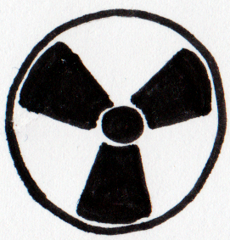  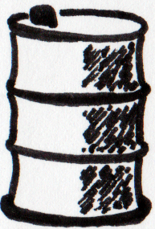  Nom  Production | Age |  |  |  |  | Coût |  | Prod. |  | Nom | Age |  |  |  |  | Coût |  |  |  | Prod.
Nuc 1 |  |  |  |  |  | 1,5 | 17 | 16 |  | Raf 1 |  |  |  |  |  | 1 | 30 | 3 | 3 | 15 | 15
Nuc 2 |  |  |  |  |  | 1,5 | 17 | 16 |  | Raf 2 |  |  |  |  |  | 1 | 30 | 3 | 3 | 15 | 15
Nuc 3 |  |  |  |  |  | 1,5 | 17 | 16 |  | Raf 3 |  |  |  |  |  | 1 | 30 | 3 | 3 | 15 | 15
Nuc 4 |  |  |  |  |  | 1,5 | 17 | 16 |  | Raf 4 |  |  |  |  |  | 1 | 30 | 3 | 3 | 15 | 15
Nuc 5 |  |  |  |  |  | 1,5 | 17 | 16 |  | Raf 5 |  |  |  |  |  | 1 | 30 | 3 | 3 | 15 | 15
Nuc 6 |  |  |  |  |  | 1,5 | 17 | 16 |  | Raf 6 |  |  |  |  |  | 1 | 30 | 3 | 3 | 15 | 15
Nuc 7 |  |  |  |  |  | 1,5 | 17 | 16 |  | Raf 7 |  |  |  |  |  | 1 | 30 | 3 | 3 | 15 | 15
Nuc 8 |  |  |  |  |  | 1,5 | 17 | 16 |  | Raf 8 |  |  |  |  |  | 1 | 30 | 3 | 3 | 15 | 15
Nuc 9 |  |  |  |  |  | 1,5 | 17 | 16 |  | Raf 9 |  |  |  |  |  | 1 | 30 | 3 | 3 | 15 | 15
Nuc 10 |  |  |  |  |  | 1,5 | 17 | 16
Nuc 11 |  |  |  |  |  | 1,5 | 17 | 16
Nuc 12 |  |  |  |  |  | 1,5 | 17 | 16
Nuc 13 |  |  |  |  |  | 1,5 | 17 | 16
Nuc 14 |  |  |  |  |  | 1,5 | 17 | 16
Total |  |  |  |  |  |  |  |  |  | Total
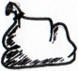
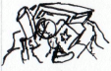
Déchets
Coûts
A enfouirEnfouis Restant
restant + nouveaux
24 +0,5 + 1 +3 = 6 + 4 + 4
valorisation énergétique
nouveaux = total – (valorisation énergétique + recyclage)
Production
enfouissage
/ : 3
= 100
x 123 =
x 6 : + + + = + +
x 7 : + =
recyclage
24 + 0,5 = 8
Import
Ressource | Tour 1 |  | Tour 2 |  | Tour 3 |  | Tour 4 |  | Tour 5 |  | Tour 6 |  | Tour 7 |  | Tour 8
Ressource | Payé | Arrive | Payé | Arrive | Payé | Arrive | Payé | Arrive | Payé | Arrive | Payé | Arrive | Payé | Arrive | Payé | Arrive
 |  | 250 |  | 100 |  | 100
 |  | 300 |  | 150 |  | 50
 |  |  |  | 50
 |  | 50 |  | 50
Coût
Ressource | Tour 1 |  |  | Tour 2 |  |  | Tour 3 |  |  | Tour 4 |  |  | Tour 5 |  |  | Tour 6 |  |  | Tour 7 |  |  | Tour 8
Nécessaire / Capacité / Produit | N | C | P | N | C | P | N | C | P | N | C | P | N | C | P | N | C | P | N | C | P | N | C | P
= +


